MAGARINI CHILDREN CENTRE AND ORGANIC FARMING DEMONSTRATION FARM

ANNUAL REPORT
FOR THE YEAR 2015
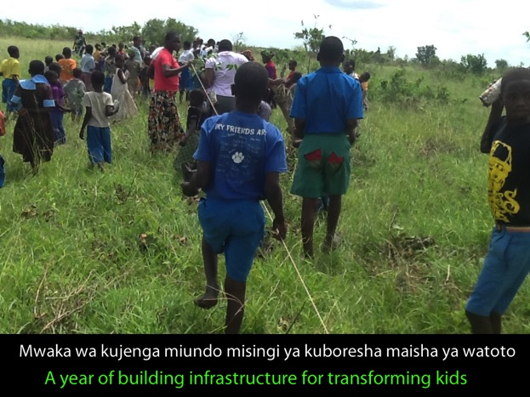
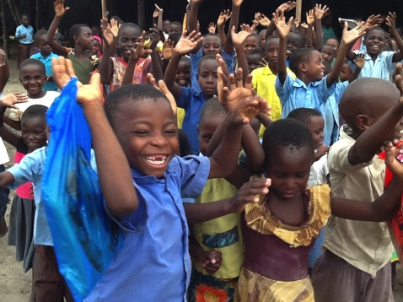
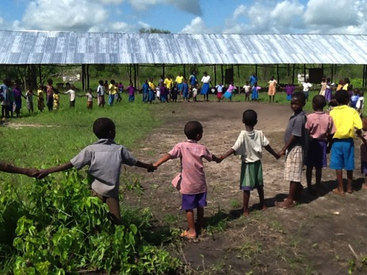
Table of Contents
1.0 Message from the Founder 4
1.1 Message from the Centre Manager 8
1.2 Message from the Farm Manager 9
2.0 Introduction 10
2.1 Vision & Mission Statements 10
2.2 Challenges and Opportunities 10
2.3 Strategic Thinking 11
3.0 Projects 14
3.1 Feeding program 14
3.2 Organic Demonstration Farm 15
3.2.1 Farm 15
3.2.2 Livestock and Pigs 17
3.3 Education 18
3.3.1 Classrooms & Desks 18
3.3.2 Dormitory 19
3.3.3 Toilets 20
3.4 Other Projects 21
3.4.1 Mosquito Nets 21
3.4.2 Tree Planting 22
3.4.2 Camping Site 23
4.0 Capacity Building 23
4.1 Training 23
5.0 Community Participation 24
6.0 Administrative Setup 25
7.0 Financial Report for the year ended 31st December 2015 26

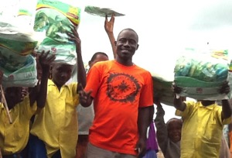
1.0 Message from the Founder
This is perhaps the most eventful year that we have witnessed at the Magarini Children Centre and Organic Farming Demonstration Farm. We made tremendous progress and met challenges in equal measure. As a founder, I can now afford to smile, looking back at what we have been able to achieve despite all the odds that were against us.
It is in 2015 that due to circumstances beyond our control we had to relocate the project from Kombo-Boma area ( Magarini Location, Bomani Sub location) to Bundacho village (Gongoni Location, Shomela Sub-location) where we are now in a sprawling 31 acres farm. The re-location meant that we had to start from scratch – put up new infrastructure for the transformation of the children. It was a daunting task but I am glad to report that as the year comes to a close, we have been able to setup make-shift structures for the children and centre is up and running!
It is still in 2015 that we were able to get funding from one of our most dedicated supporters, who has single handedly continued to fund a massive dormitory project to provide shelter to 100 vulnerable girls in the community. The project is now on course and is scheduled to be completed in 2016 – Thanks to the generous support from AYAKO HAYASHIDA from Japan.
The year 2015 also saw us start a toilet project for the children. This is a great step in promoting sanitation in the community. The children will be able to access standardized sanitation facilities and in the process, we will inculcate in them the values of good sanitation which they will in turn practice both in school and at home. This will bring to an end the age old deplorable habit of “going to the bush” to defecate.
It is in 2015 that we also setup a makeshift housing unit for the teachers and caregivers at the farm. The houses are temporary, made of mud and iron roofing. This makes it convenient for the teachers and caregivers to attend to the children. We intend to scale up this initiative and ensure that all the people dealing with the children are also taken care of by the project so that the benefits of the project are multiplied and amplified. All the teachers and caregivers will have an opportunity to fully participate in the life of the children as they will also participate in the organic farming project, both for the institution and at a personal level.
For the first time this year all the children at the centre went for an educational tour in the nearest town they were so happy to learn many new things they really enjoyed and appreciated
It is in 2015 that we started a pig rearing unit, a poultry unit, a new demonstration farm and engaged in organic farming that yielded the following harvest: Corn (maize) – 30 bags, Tomatoes (1 tonne) and Water Melon (10 tonnes). This harvest and initiatives have gone a long way in promoting the food security for the centre.
It is still in 2015 that we distributed over 160 mosquito nets to all the children, ensuring that the fight against malaria is maintained in top gear. The nets initiative was supported by Sage Sharon Emery from the United States of America. The centre is also in the process of establishing a campsite to host visitors who prefer to stay in a camp at the Centre. To this end the centre has acquired a number of tents that are available for hire. This is an income generating activity for the centre.
The year ended on a high and celebratory note with the children, and community members being invited to a Christmas party, where special food and a delicacy to the coastal people, Pilau (rice with goat meat) was prepared. There was a lot of food for everyone and the forum also provided a good opportunity for the community to interact with the project staff, and also give feedback to the project team.
May take this opportunity to thank our entire supporter from all over the world for their Love Care and Continued support, together we made a huge difference in the life of the children, Teachers and all the community at large we have achieved great results this year because of your generous giving than you so much as the founder I am incredible touched and feel privileged to have you all my dear friends, Sister and Brothers.
Emmanuel Karisa Baya
Founder Magarini Children Centre and Organic Faming Demonstration Farm
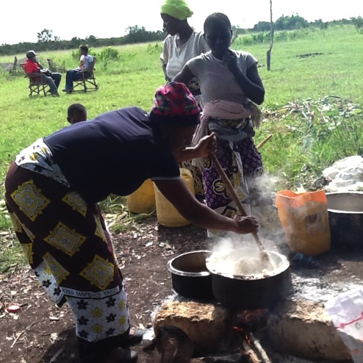
Preparing food for the Christmas party
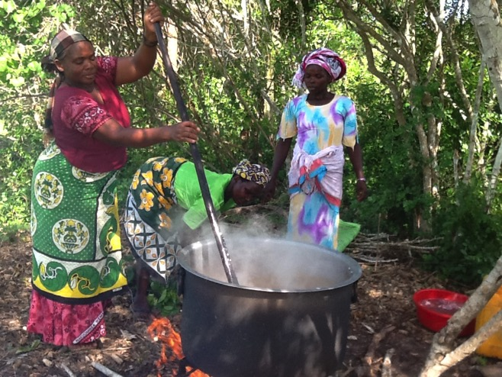
Members of the community participate in preparing food for the Christmas Celebrations

1.1 Message from the Centre Manager
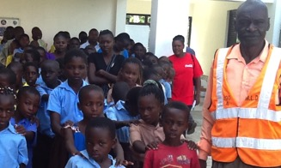
The Centre Manager Mr. James Kirimo Menza with some of the children during a recent school education trip
Ladies and Gentlemen, the greatest gift one can give to a marginalized child is education. The centre opened its doors in May 2015 at the new location thanks to the generous contribution of well wishers. Despite the challenges including temporary building infrastructure and inadequate instructional materials, the child continued getting the required education.
I wish to take this opportunity to thank the Board of Management for their tireless effort to make the learning of the child continue operating. I would like to give more tribute to friends and well wishers from both in and outside Kenya for their immense contributions and continued support to our children centre.
It is my hope that with this continued support, the centre will positively change. May I, this day, take this opportunity to wish everyone a Merry Christmas and a happy new year.
Thank you
James Kirimo Menza.
Centre Manager

1.2 Message from the Farm Manager
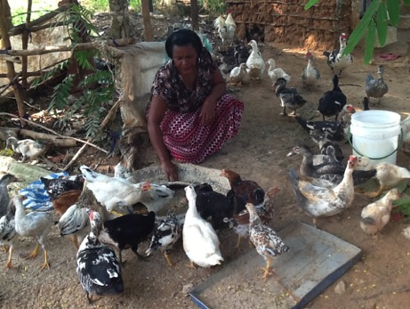
The soil is communicating to all people of the world that it’s time for all of us to take care of the soil. It is clear though that climate change is a threat to all of us. It’s in this regard here at Magarini Children Centre we have been promoting pure organic farming for the growing of safe, healthy food and taking care of the soil, by not using any chemical.
It’s clear that the most affected people are those living in extreme poverty and exclusion. That’s why we train members of the community on the importance of planting trees and conserving the existing small forest. We use the “learning by doing approach” to our training for both community members and the children whom we encourage to adapt organic farming from an early age.
I wish to thank all our supporters together with us share this dream and making this earth a better place for all. I thank you all for your love and continued support.
Merry Christmas and Happy New Year 2016

Jescar Mbuche Shehe
Farm Manager and Organic farming expert.

2.0 Introduction
Magarini Children’s Centre and Demo Farm is a registered Community-based Organization under Kenyan law. It was formed in 2008 as a community initiative to provide care and education to children who had lost their parents through HIV/AIDS as well as other homeless and vulnerable children in a region that struggles with extreme poverty.
Long Term Goal: Build the communities capacity to secure their own food, nutrition and income at household level to alleviate poverty.
MCCOFDF mainly focuses on sustainable improvement of livelihoods of small scale farmers through sustainable agriculture and in particular organic farming, a system of farming using locally available materials to improve the soil, yield and farmers standards of living.

2.1 Vision & Mission Statements
MCCOFDF’s Mission Statement: To nurture children to be self reliant individuals through a dynamic curriculum that entails: hard work, discipline, spiritual build up, social cohesiveness and moral values.
Vision: The overall goal is to build a self reliant, independent community where all people grow their own food, through sustainable agriculture where people will take care of the soil, environment and Nature for the benefit of the future generation

Core Values:
  - Respect and promotion of indigenous African knowledge on the farming, care-giving and community development
  - Equality for all: God made all people equal; our organization is committed to a development process that promotes equality.(Gender Equality)
  - Rights and dignity for all: We believe in and strive to uphold the rights and dignity of all people especially in the rural communities.(Girl Child Eduacation)
  - Stewardship: We believe in God to protect the dignity of everybody to exploit the Earthy goods in accordance with God’s Law and individual order.
  - Institutional partnership in development: We welcome and respect ongoing International initiatives and national policies to take care and give support to vulnerable children and disadvantaged people fight poverty, ignorance and diseases such as Malaria, Immunizable diseases and HIV/AIDS.

2.2 Challenges and Opportunities
The year had its share of challenges and opportunities. It is encouraging to note that despite all the difficulties that we experienced as a project team, we were still able to achieve very encouraging results. We sincerely thank our supporters for the continuing support they have always provided to the project.
Opportunities
- 31 acre farm at Bundacho Village
- Support from the local community
- Conducive operating environment
Challenges
- Inadequate funding for scheduled activities
- Overwhelming needs of the community against resources available
- Illiteracy in the community
- Retrogressive cultural practices

2.3 Strategic Thinking
In the years ahead the organization is planning to pursue the following strategic pathways:
- Education
- Early Child Development (ECD)
Strengthen the Early Child Development unit at the centre so that it can serve more children in the community and at the same time, do so in an effective way embracing the value for money principle.
- PRIMARY SCHOOL SECTION
Complete a primary school block to accommodate children from class 1 to class 8 by the year 2019
- DORMITORY
Complete the ongoing dormitory for girls by April 2016 with a capacity to accommodate 100 girls. The dormitory will be a self contained unit with inbuilt toilet facilities, study area and space for a matron to live in.
- TOILETS
Complete toilets for the entire centre to serve the children, staff and also the public by February 2016. The school intends to setup a public toilet facility to set up standards for the community to emulate.
- SECONDARY SCHOOL SECTION
The centre intends to setup a secondary school section by 2020 to accommodate the children who graduate from the primary school section. The secondary school will also admit students from other primary schools in the area and serve as a centre of excellence in secondary school education in the region.
- STAFF
Provide free housing within the project and encourage staff embrace the practice of taking good care of the soil in line with the centers motto : Caring for the soil is caring for ourselves and the world!
- COMMUNITY LIBRARY
To setup a fully equipped Community Library to serve the community By December 2016. In this initiative, we call upon well wishers to join us in raising the required resources both in cash and in kind. We wish to recognize the effort and thought-process by the GBS TV Fraternity on this matter.
- Organic Farming
The project proposes to upscale the organic farming demonstration and seek to enhance the farming knowledge and practices of the local community. This initiative aims at not only enhancing food security in the community but also ensuring that food is grown safely for both human and domestic animal consumption. Inculcating responsible environmental stewardship is also a key focus of this initiative.
Linkages with both local and international institutions offering training in agriculture such as the Asian Rural Institute in Japan will be actively sought.
- Feeding Program
The feeding program will continue and it is expected that the families of the children will be integrated in the organic farming initiative to expand the scope of the program to include ensuring food security for the entire family of each child.
The project will also seek to partner with existing relief organizations to offer logistical support to the distribution of relief food. The centre will strive to become a centre of excellence in building food security for the local community.
To fully support the 152 children at the centre, the project requires at least USD$200 per day to provide breakfast and lunch to all the children.
- Other initiatives
The organization is in the process of rebranding and seeking to position herself in the civil society landscape in the Coast Region. The process will enhance the corporate image of the organization and strengthen her networks.
The organization is also in the process of strengthening her systems and policies for project management including financial systems, reporting systems and the monitoring and evaluation framework. This will enable the organization to benchmark with other national organizations enabling the organization to seek formal funding from institutional donors.
To this end the organization has partnered with Designed Solutions Africa, a local consultancy firm with a lot of experience and expertise in these areas, to progressively strengthen her capacities.

3.0 Projects

3.1 Feeding program
The feeding program is ongoing throughout the year term. We give the children breakfast before they start class in the morning and also give them lunch. The feeding program is very instrumental in the learning and development process of the children. All the children come from vulnerable families, who survive on less than one dollar a day. The families are mostly peasant farmers, who only rely on the unpredictable rainfall pattern for farming. They are subsistence farmers who only grow food – mostly maize (corn) for their own consumption. Due to poor farming practices and unreliable rainfall patterns, they end up with little or nothing in terms of harvest. These families mostly survive on relief food programs provided by t he government and relief organizations. They can barely afford to feed their families, have no access healthcare system – being forced to rely on traditional herbs and in some cases, rely on over the counter medication from pharmacies, most of which are neither licensed nor manned by professionals. In this kind of scenario, schooling then becomes an expensive luxury the families cannot afford as they would rather have the children help them in the farms and taking care of animals. The feeding project is therefore fulfilling a very big gap in the community. It not only ensures that the children are getting the basic nutrition they need for growth and development but also helps to maintain them in school.
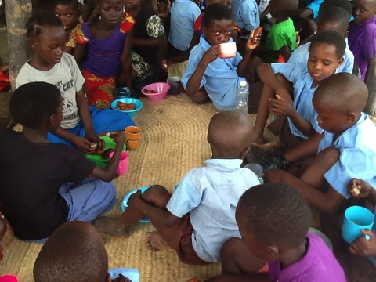
Children taking breakfast before starting the school day.

3.2 Organic Demonstration Farm

3.2.1 Farm

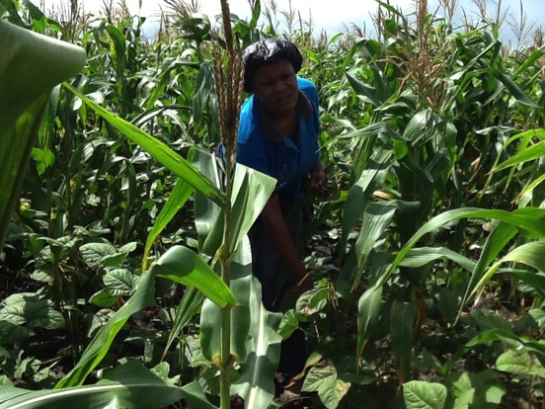
The centre has setup two demonstration farm units. The first demonstration farm unit is located at the centre within the 31 acre farm at Bundacho village and the other one is located on the main road to Marafa trading centre at Vithunguni.
The demonstration unit that is located at the centre is mostly used to train children in organic farming techniques. They learn how to care for the soil and the environment. In this way the children learn to take care of themselves and the world around them.
The demonstration unit at Vithunguni is mainly for training members of the community in organic farming. The following are the key techniques that we train the farmers in:
- Making organic fertilizer
- Making organic pesticides
- Compost Making
- Mixed cropping
- Leadership and Group Dynamics
- Pig rearing
- Poultry farming (Indigenous Ducks & Chicken)
The harvest from the demonstration farms is used as food for the children at the centre. In 2015 we harvested water melons from the demonstration farm and the proceeds of the sale of the water melons was used to support the centre.
In 2015, a total of seven (7) farmers from six(6) villages were trained on organic farming. This brings the total number of farmers trained and practicing organic farming to forty-two (42) farmers spread in over 9 villages.
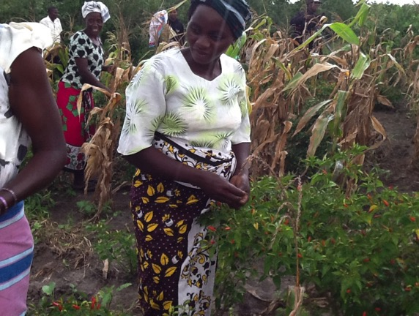
Members of the community harvesting corn (maize) and chilli pepper at the demonstration unit
3.2.2 Livestock and Pigs
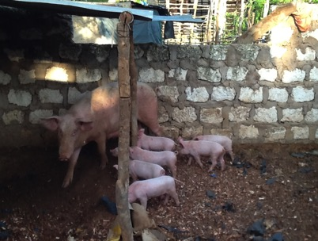
In 2015 we purchased 2 pigs for the pig unit. The unit is intended to support the centre with the income from the sale of the pigs. It will also enable the children to learn how to take care of animals. This will help them understand that in life there are animals which can help in providing food and income from the sale of the animals.
We also started a poultry unit, keeping indigenous chicken and ducks.
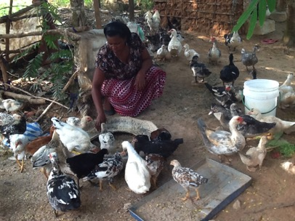

3.3 Education

3.3.1 Classrooms & Desks
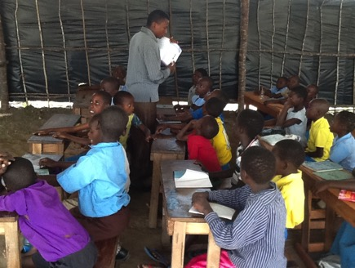
We started to build make-shift classrooms for the children to enable them to continue with their schooling after the relocation from Kombo-boma. The classrooms are made from iron sheet roofing and poles from causorina tree. The classrooms have not been subdivided and the floor is still made of mud. A total of five (5) classrooms were constructed to accommodate the 152 children at the centre from class 1 to class 5.
The classes are not yet finished. Partitions to divide the classes are needed including walling and the floors.
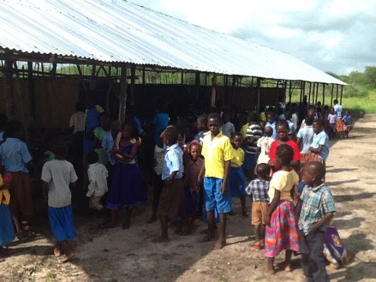
3.3.2 Dormitory

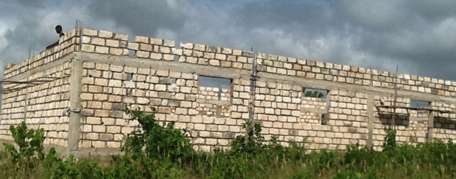
The construction of the girls dormitory is proceeding according to plan. The dormitory has a capacity of upto 100 girls, inbuilt toilets, a study area and wardrobes and a housing unit for a matron. The dormitory is scheduled to be completed by April 2016.
Upon completion, the dormitory will provide accommodation to vulnerable girls, majority of whom are now staying with host families in the local community. The facility is a bold step in the right direction in the fight for the girl child. The facility will not only act as a safe house for girls at risk but at the same time provide shelter to girls who would otherwise be homeless.
The dormitory initiative is fully funded by AYAKO HAYASHIDA from Japan.

3.3.3 Toilets
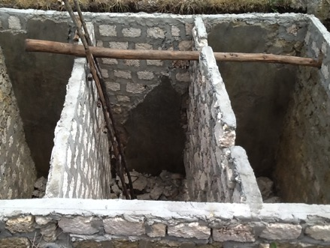
The centre started a massive toilets project aimed at contributing to the enhancement of water and sanitation facilities for the children. The toilets when fully completed will be made up of a girls unit, a boys unit, a teachers unit and a public access unit to enable the local community to access standardized toilet facilities.
The initiative will also become a benchmarking facility, enabling the local community to emulate the setup of the toilets.

3.4 Other Projects

3.4.1 Mosquito Nets

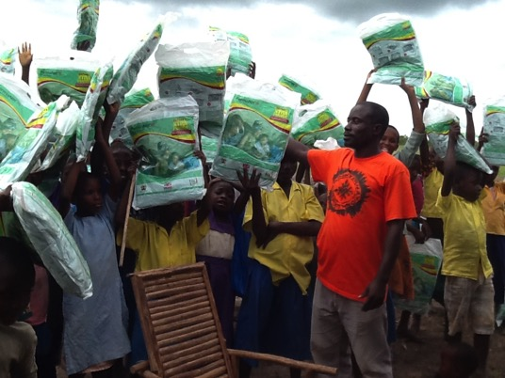
The current project site at Bundacho and indeed the entire coastal region is known to be one of the areas with the highest prevalence of malaria. The fight against malaria is therefore important and necessary if the mortality rates of children under 5 years are to be brought down.
Through the generous donation by Sage SHARON Emery from the United States of America, the centre was able to acquire and distribute over 160 mosquito nets to the children at the centre. We appeal to more well wishers both individual and institutional to continue supporting us on this war against malaria.
3.4.2 Tree Planting

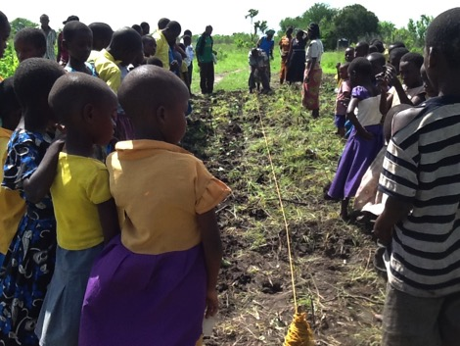
In order to inculcate in the children values that promote the taking care of the soil and the environment, the project progressively ensures that at least 500 trees are planted every rainy season.
Each child is prepared to take care of at least three tree s each year.
3.4.2 Camping Site
The centre has also set aside grounds for use as a full-serviced campsite. Currently some tents are already in place for visitors to hire at a modest fee. Camping tents were donated by OneWorld from Germany Dresen community

4.0 Capacity Building

4.1 Training
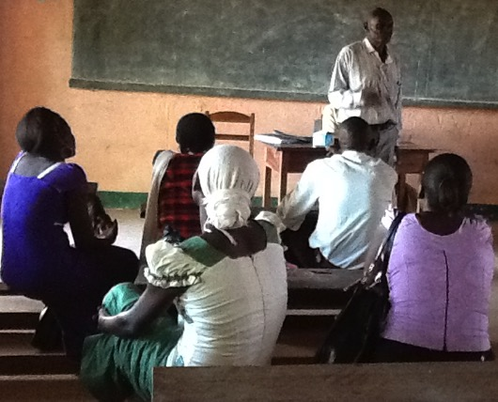
Staff capacity building enhancement is an ongoing process to ensure that the staff dealing with the children have the required skills and experience to competently handle children.

5.0 Community Participation
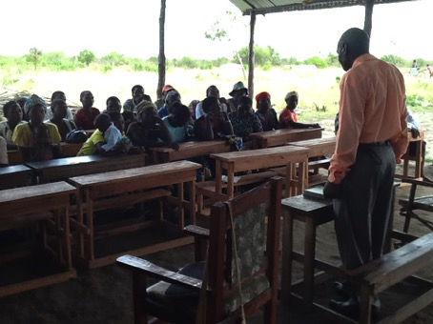
The centre has built around it a large constituency from the local community who are actively involved in the project. The community actively participates in the planning, implementation and monitoring and evaluation of the activities of the centre. The local community forms the bulk of the farmers who attend the training sessions at the demonstration farm.
6.0 Administrative Setup

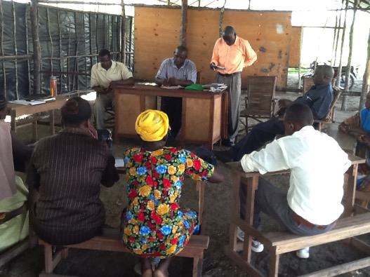
The centre is run by a team of professionals who are dedicated at ensuring that the project attains value for money standards.
The centre is headed by an Executive Director, who is also the Founding Director. Directly under him and incharge of the day to day affairs of the centre, are two competent managers. The centre manager and the Farm Manager.
The Farm manager is in charge of anything that revolves around farming including the demonstration farms for both community members and the children.
The centre manager on the other hand is in charge of all the educational matters of the centre including providing leadership to the teaching staff
The centre also has two subordinate staff that are in charge of security

7.0 Financial Report for the year ended 31st December 2015
The following is the Income and Expenditure statement for the centre for the year ended 31st December 2015
INCOME AND EXPENDITURE FOR THE YEAR ENDED 31 DECEMBER 2015
INCOME & DONATIONS 2015 | KES | USD$ @95
INCOME AND DONATIONS
Barbara Kaluche (One world) | 738,000.00 | $ 7,768.42
Stephen Schrodder (USA) | 57,000.00 | $ 600.00
Neil Schrodder (USA) | 47,500.00 | $ 500.00
Rita (Poland) | 44,800.00 | $ 471.58
Alex Bulkin | 300,000.00 | $ 3,157.89
International Group for Peace (Geny & Sage) | 385,225.00 | $ 4,055.00
Kai Snell (USA) | 98,000.00 | $ 1,031.58
Ayako Hayashida (Japan) | 2,326,196.00 | $ 24,486.27
Larry Glover ( USA) | 260,000.00 | $ 2,736.84
Wayne (USA) | 28,000.00 | $ 294.74
Sales Income from Farm produce | 327,500.00 | $ 3,447.37
Total Income and Donations | 4,612,221.00 | $ 48,549.69
EXPENDITURE 2015 | KES | USD $ @95
Dormitory Construction Expenses | 1,856,196.00 | $ 19,538.91
Make-shift Classrooms construction | 540,000.00 | $ 5,684.21
Salaries and Wages for staff | 1,048,000.00 | $ 11,031.58
Text books | 160,000.00 | $ 1,684.21
Stationery | 72,000.00 | $ 757.89
Desks | 100,000.00 | $ 1,052.63
Mosquito Nets | 98,000.00 | $ 1,031.58
Host family support | 210,000.00 | $ 2,210.53
Medical expenses | 120,000.00 | $ 1,263.16
Toilet Construction expenses | 270,000.00 | $ 2,842.11
Purchase of Camping Tents | 76,000.00 | $ 800.00
Board Meetings and expenses | 120,000.00 | $ 1,263.16
Total Expenditure for the year 2015 | 4,670,196.00 | $ 49,159.96
DEFICIT / SURPLUS | (57,975.00) | $ (610.26)

